Laporan Percobaan 1

Tag Device : iTAG

Beacon Device : ESP32

Durasi Pengambilan data tiap ruang : 3 menit

Denah ruangan

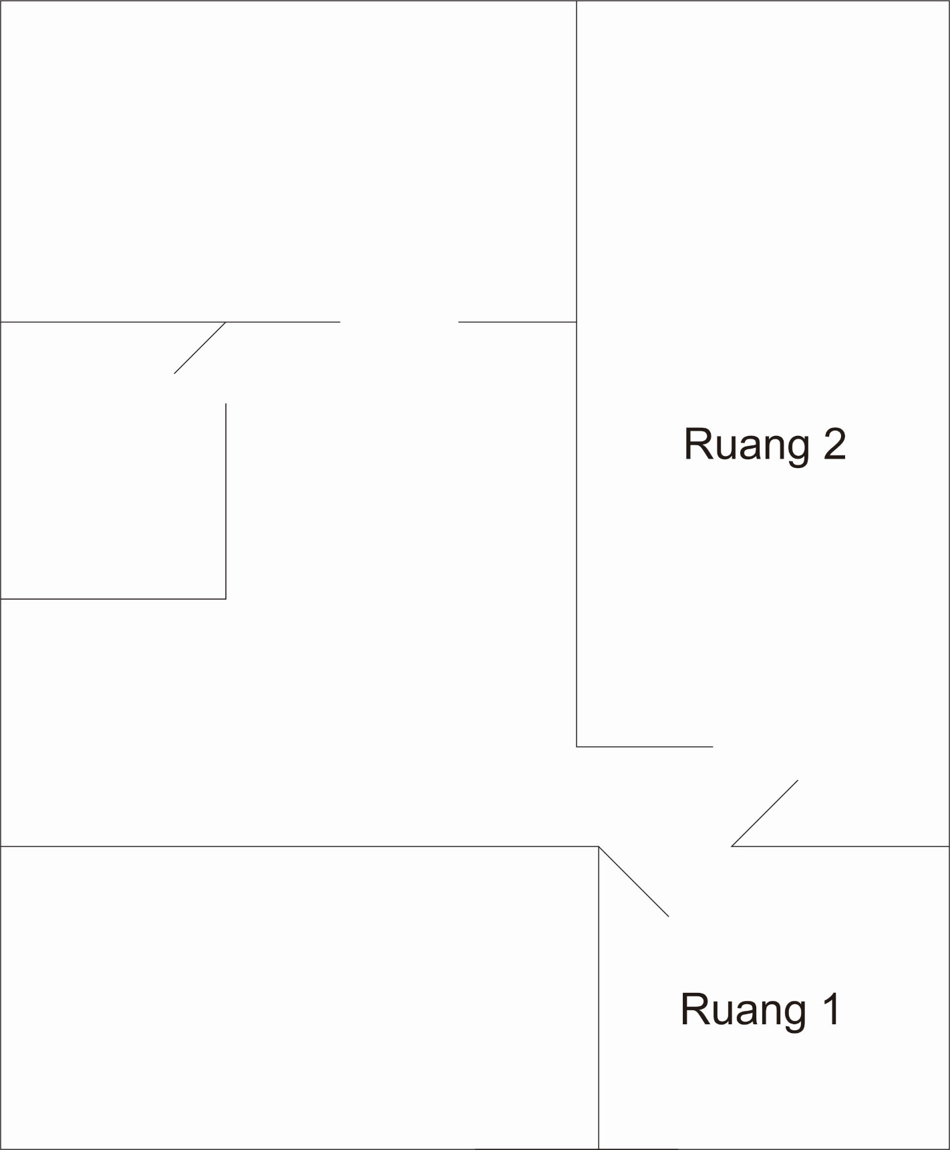

Gathering Data Result

|  |  |  |  |
| --- | --- | --- | --- |
| ruang | date_time | beacon1 | beacon2 |
| Ruang 1 | 07:28:12 | -69 | 0 |
| Ruang 1 | 07:28:15 | -67 | 0 |
| Ruang 1 | 07:28:17 | 0 | -91 |
| Ruang 1 | 07:28:19 | -81 | 0 |
| Ruang 1 | 07:28:20 | -69 | 0 |
| Ruang 1 | 07:28:21 | -67 | -94 |
| Ruang 1 | 07:28:21 | -70 | -86 |
| Ruang 1 | 07:28:22 | -73 | -88 |
| Ruang 1 | 07:28:22 | -72 | -88 |
| Ruang 1 | 07:28:24 | -81 | -96 |
| Ruang 1 | 07:28:25 | -72 | 0 |
| Ruang 1 | 07:28:27 | -74 | 0 |
| Ruang 1 | 07:28:28 | -80 | 0 |
| Ruang 1 | 07:28:30 | -74 | 0 |
| Ruang 1 | 07:28:31 | -82 | 0 |
| Ruang 1 | 07:28:34 | -73 | 0 |
| Ruang 1 | 07:28:37 | -74 | 0 |
| Ruang 1 | 07:28:39 | -74 | 0 |
| Ruang 1 | 07:28:40 | -75 | 0 |
| Ruang 1 | 07:28:43 | -80 | 0 |
| Ruang 1 | 07:28:45 | -74 | 0 |
| Ruang 1 | 07:28:47 | -73 | 0 |
| Ruang 1 | 07:28:50 | -74 | 0 |
| Ruang 1 | 07:28:51 | -80 | 0 |
| Ruang 1 | 07:28:53 | -74 | 0 |
| Ruang 1 | 07:28:54 | -74 | 0 |
| Ruang 1 | 07:28:56 | -74 | 0 |
| Ruang 1 | 07:28:57 | -80 | 0 |
| Ruang 1 | 07:28:59 | -74 | 0 |
| Ruang 1 | 07:29:00 | -73 | 0 |
| Ruang 1 | 07:29:02 | -73 | 0 |
| Ruang 1 | 07:29:04 | -82 | 0 |
| Ruang 1 | 07:29:07 | -81 | 0 |
| Ruang 1 | 07:29:08 | -82 | 0 |
| Ruang 1 | 07:29:11 | -75 | 0 |
| Ruang 1 | 07:29:14 | -74 | 0 |
| Ruang 1 | 07:29:16 | -74 | 0 |
| Ruang 1 | 07:29:17 | -74 | 0 |
| Ruang 1 | 07:29:19 | -81 | 0 |
| Ruang 1 | 07:29:22 | -81 | 0 |
| Ruang 1 | 07:29:25 | -81 | 0 |
| Ruang 1 | 07:29:27 | -74 | 0 |
| Ruang 1 | 07:29:28 | -73 | 0 |
| Ruang 1 | 07:29:30 | -74 | 0 |
| Ruang 1 | 07:29:34 | -73 | 0 |
| Ruang 1 | 07:29:36 | -74 | 0 |
| Ruang 1 | 07:29:37 | -75 | 0 |
| Ruang 1 | 07:29:39 | -73 | 0 |
| Ruang 1 | 07:29:41 | -75 | 0 |
| Ruang 1 | 07:29:42 | -80 | 0 |
| Ruang 1 | 07:29:44 | -73 | 0 |
| Ruang 1 | 07:29:45 | -74 | 0 |
| Ruang 1 | 07:29:47 | -81 | 0 |
| Ruang 1 | 07:29:48 | -74 | 0 |
| Ruang 1 | 07:29:50 | -73 | 0 |
| Ruang 1 | 07:29:51 | -74 | 0 |
| Ruang 1 | 07:29:53 | -75 | 0 |
| Ruang 1 | 07:29:57 | -80 | 0 |
| Ruang 1 | 07:30:01 | -82 | 0 |
| Ruang 1 | 07:30:04 | -73 | 0 |
| Ruang 1 | 07:30:10 | -80 | 0 |
| Ruang 1 | 07:30:13 | -83 | 0 |
| Ruang 1 | 07:30:16 | -75 | 0 |
| Ruang 1 | 07:30:30 | -75 | 0 |
| Ruang 1 | 07:30:39 | -82 | 0 |
| Ruang 1 | 07:30:42 | -78 | 0 |
| Ruang 1 | 07:30:44 | -73 | 0 |
| Ruang 1 | 07:30:44 | -65 | -85 |
| Ruang 1 | 07:30:45 | -79 | -85 |
| Ruang 1 | 07:30:45 | -78 | -87 |
| Ruang 1 | 07:30:46 | -69 | -95 |
| Ruang 1 | 07:30:48 | -64 | 0 |
| Ruang 1 | 07:30:49 | -65 | -96 |
| Ruang 1 | 07:30:51 | -65 | 0 |
| Ruang 1 | 07:30:52 | -64 | 0 |
| Ruang 1 | 07:30:54 | -63 | 0 |
| Ruang 1 | 07:30:57 | -67 | 0 |
| Ruang 1 | 07:30:58 | -71 | 0 |
| Ruang 1 | 07:30:59 | -67 | -90 |
| Ruang 1 | 07:31:00 | -65 | -93 |
| Ruang 1 | 07:31:00 | -67 | -90 |
| Ruang 1 | 07:31:01 | -70 | -88 |
| Ruang 1 | 07:31:02 | -67 | -91 |
| Ruang 1 | 07:31:02 | -66 | -88 |
| Ruang 1 | 07:31:04 | -68 | -88 |
| Ruang 1 | 07:31:05 | -65 | -89 |
| Ruang 1 | 07:31:07 | -69 | -91 |
| Ruang 1 | 07:31:08 | -69 | 0 |
| Ruang 1 | 07:31:10 | -63 | 0 |
| Ruang 1 | 07:31:11 | -69 | 0 |
| Ruang 1 | 07:31:13 | -64 | 0 |
| Ruang 1 | 07:31:14 | -69 | 0 |
| Ruang 1 | 07:31:17 | -69 | 0 |
| Ruang 2 | 07:31:47 | -92 | -76 |
| Ruang 2 | 07:31:49 | 0 | -68 |
| Ruang 2 | 07:31:49 | -92 | -70 |
| Ruang 2 | 07:31:51 | -93 | 0 |
| Ruang 2 | 07:31:51 | -90 | -69 |
| Ruang 2 | 07:31:52 | -91 | -72 |
| Ruang 2 | 07:31:54 | -91 | 0 |
| Ruang 2 | 07:31:54 | -91 | -69 |
| Ruang 2 | 07:31:56 | 0 | -69 |
| Ruang 2 | 07:31:57 | 0 | -68 |
| Ruang 2 | 07:31:58 | -95 | -68 |
| Ruang 2 | 07:32:00 | -97 | -69 |
| Ruang 2 | 07:32:01 | 0 | -68 |
| Ruang 2 | 07:32:02 | -94 | -72 |
| Ruang 2 | 07:32:02 | -95 | -72 |
| Ruang 2 | 07:32:03 | -95 | -72 |
| Ruang 2 | 07:32:04 | -93 | -69 |
| Ruang 2 | 07:32:06 | 0 | -69 |
| Ruang 2 | 07:32:07 | -92 | -72 |
| Ruang 2 | 07:32:08 | -94 | -68 |
| Ruang 2 | 07:32:09 | -91 | -69 |
| Ruang 2 | 07:32:10 | -89 | 0 |
| Ruang 2 | 07:32:11 | 0 | -69 |
| Ruang 2 | 07:32:13 | -92 | -69 |
| Ruang 2 | 07:32:14 | -94 | -72 |
| Ruang 2 | 07:32:15 | 0 | -72 |
| Ruang 2 | 07:32:16 | -94 | -69 |
| Ruang 2 | 07:32:17 | -96 | -70 |
| Ruang 2 | 07:32:18 | -93 | -69 |
| Ruang 2 | 07:32:18 | -93 | -69 |
| Ruang 2 | 07:32:20 | 0 | -72 |
| Ruang 2 | 07:32:21 | -94 | -70 |
| Ruang 2 | 07:32:22 | -92 | -68 |
| Ruang 2 | 07:32:23 | -94 | -68 |
| Ruang 2 | 07:32:23 | -93 | -69 |
| Ruang 2 | 07:32:24 | -93 | -70 |
| Ruang 2 | 07:32:25 | -96 | -69 |
| Ruang 2 | 07:32:26 | -94 | -69 |
| Ruang 2 | 07:32:27 | -93 | -69 |
| Ruang 2 | 07:32:28 | 0 | -69 |
| Ruang 2 | 07:32:29 | -95 | -72 |
| Ruang 2 | 07:32:30 | 0 | -69 |
| Ruang 2 | 07:32:32 | 0 | -69 |
| Ruang 2 | 07:32:33 | -90 | -68 |
| Ruang 2 | 07:32:34 | 0 | -69 |
| Ruang 2 | 07:32:35 | -90 | -68 |
| Ruang 2 | 07:32:37 | 0 | -69 |
| Ruang 2 | 07:32:38 | -96 | -69 |
| Ruang 2 | 07:32:39 | -93 | -69 |
| Ruang 2 | 07:32:40 | -94 | -71 |
| Ruang 2 | 07:32:41 | -88 | 0 |
| Ruang 2 | 07:32:42 | -95 | -75 |
| Ruang 2 | 07:32:42 | -90 | -74 |
| Ruang 2 | 07:32:43 | -90 | -73 |
| Ruang 2 | 07:32:44 | -93 | -69 |
| Ruang 2 | 07:32:44 | -91 | -73 |
| Ruang 2 | 07:32:45 | -91 | -70 |
| Ruang 2 | 07:32:45 | -90 | -74 |
| Ruang 2 | 07:32:47 | 0 | -69 |
| Ruang 2 | 07:32:47 | -94 | -74 |
| Ruang 2 | 07:32:48 | -95 | -70 |
| Ruang 2 | 07:32:49 | -93 | -69 |
| Ruang 2 | 07:32:50 | -90 | -69 |
| Ruang 2 | 07:32:51 | -94 | -69 |
| Ruang 2 | 07:32:52 | 0 | -73 |
| Ruang 2 | 07:32:53 | -89 | -73 |
| Ruang 2 | 07:32:53 | -95 | -69 |
| Ruang 2 | 07:32:55 | -92 | -69 |
| Ruang 2 | 07:32:55 | -92 | -69 |
| Ruang 2 | 07:32:57 | -95 | 0 |
| Ruang 2 | 07:32:58 | 0 | -69 |
| Ruang 2 | 07:32:59 | -93 | -70 |
| Ruang 2 | 07:33:00 | 0 | -74 |
| Ruang 2 | 07:33:03 | 0 | -69 |
| Ruang 2 | 07:33:04 | -92 | -69 |
| Ruang 2 | 07:33:05 | -91 | -73 |
| Ruang 2 | 07:33:05 | -91 | -69 |
| Ruang 2 | 07:33:07 | -90 | 0 |
| Ruang 2 | 07:33:08 | -91 | -69 |
| Ruang 2 | 07:33:09 | -90 | -68 |
| Ruang 2 | 07:33:10 | 0 | -74 |
| Ruang 2 | 07:33:11 | -91 | 0 |
| Ruang 2 | 07:33:12 | -92 | -69 |
| Ruang 2 | 07:33:12 | -90 | -73 |
| Ruang 2 | 07:33:14 | 0 | -69 |
| Ruang 2 | 07:33:14 | -91 | -74 |
| Ruang 2 | 07:33:16 | -91 | 0 |
| Ruang 2 | 07:33:17 | -91 | -70 |
| Ruang 2 | 07:33:19 | 0 | -69 |
| Ruang 2 | 07:33:20 | -90 | 0 |
| Ruang 2 | 07:33:22 | -91 | 0 |
| Ruang 2 | 07:33:23 | -94 | -74 |
| Ruang 2 | 07:33:24 | -92 | -69 |
| Ruang 2 | 07:33:25 | -92 | -74 |
| Ruang 2 | 07:33:26 | -91 | -69 |
| Ruang 2 | 07:33:28 | 0 | -69 |
| Ruang 2 | 07:33:28 | -90 | -69 |
| Ruang 2 | 07:33:29 | -89 | -68 |
| Ruang 2 | 07:33:30 | -91 | -73 |
| Ruang 2 | 07:33:31 | 0 | -70 |
| Ruang 2 | 07:33:32 | -90 | -73 |
| Ruang 2 | 07:33:33 | -90 | 0 |
| Ruang 2 | 07:33:34 | -90 | -69 |
| Ruang 2 | 07:33:35 | -91 | -74 |
| Ruang 2 | 07:33:36 | -93 | -70 |
| Ruang 2 | 07:33:38 | 0 | -69 |
| Ruang 2 | 07:33:39 | -91 | -73 |
| Ruang 2 | 07:33:41 | 0 | -69 |
| Ruang 2 | 07:33:43 | -91 | -69 |
| Ruang 2 | 07:33:44 | -92 | -69 |
| Ruang 2 | 07:33:44 | -92 | -69 |
| Ruang 2 | 07:33:45 | -92 | -68 |
| Ruang 2 | 07:33:46 | -90 | -69 |
| Ruang 2 | 07:33:47 | 0 | -69 |
| Ruang 2 | 07:33:48 | -98 | -74 |
| Ruang 2 | 07:33:50 | -86 | -69 |
| Ruang 2 | 07:33:50 | -90 | -72 |
| Ruang 2 | 07:33:51 | -92 | -65 |
| Ruang 2 | 07:33:51 | -93 | -67 |
| Ruang 2 | 07:33:52 | -93 | -66 |
| Ruang 2 | 07:33:52 | -87 | -70 |
| Ruang 2 | 07:33:53 | -95 | -65 |
| Ruang 2 | 07:33:54 | -93 | -65 |
| Ruang 2 | 07:33:55 | -91 | -66 |
| Ruang 2 | 07:33:56 | -92 | 0 |
| Ruang 2 | 07:33:56 | -93 | -69 |
| Ruang 2 | 07:33:57 | -94 | -67 |
| Ruang 2 | 07:33:58 | -94 | -69 |
| Ruang 2 | 07:33:59 | 0 | -67 |
| Ruang 2 | 07:34:00 | -93 | -69 |
| Ruang 2 | 07:34:01 | -93 | -66 |
| Ruang 2 | 07:34:01 | -91 | -69 |
| Ruang 2 | 07:34:11 | 0 | -66 |
| Ruang 2 | 07:34:15 | 0 | -66 |